Short documentation and system specification

<title comes here…>

1 Introduction 2

1.1 Assignment 2

1.2 Vision 2

2 Requirements 3

3 System overview 4

3.1 System idea 4

3.2 Actors and systems 4

3.3 Use cases 4

4 Architectural and design decisions 5

4.1 Models and views 5

4.1.1 Deployment diagram 5

4.2 Data and data structures 5

4.3 Design patterns 5

5 Interfaces 6

5.1 External interfaces 6

5.2 Internal interfaces 6

5.3 User interfaces 6

6 Environment requirements 7

7 Installation and setup 8

7.1 Preconditions 8

# Introduction

## Assignment

…

## Vision

…

# Requirements

…

# System overview

## System idea

## Actors and systems

<diagram of the context>

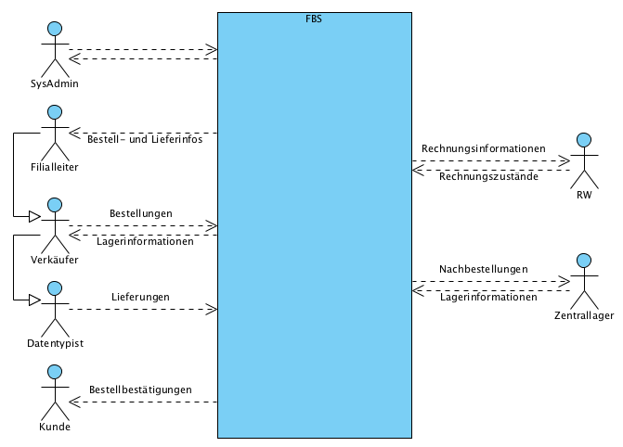

## Use cases

…

# Architectural and design decisions

## Models and views

…

### Deployment diagram

…

## Data and data structures

…

## Design patterns

…

# Interfaces

## External interfaces

…

## Internal interfaces

…

## User interfaces

…

# Environment requirements

…

# Installation and setup

## Preconditions

…